**UI Mockup**

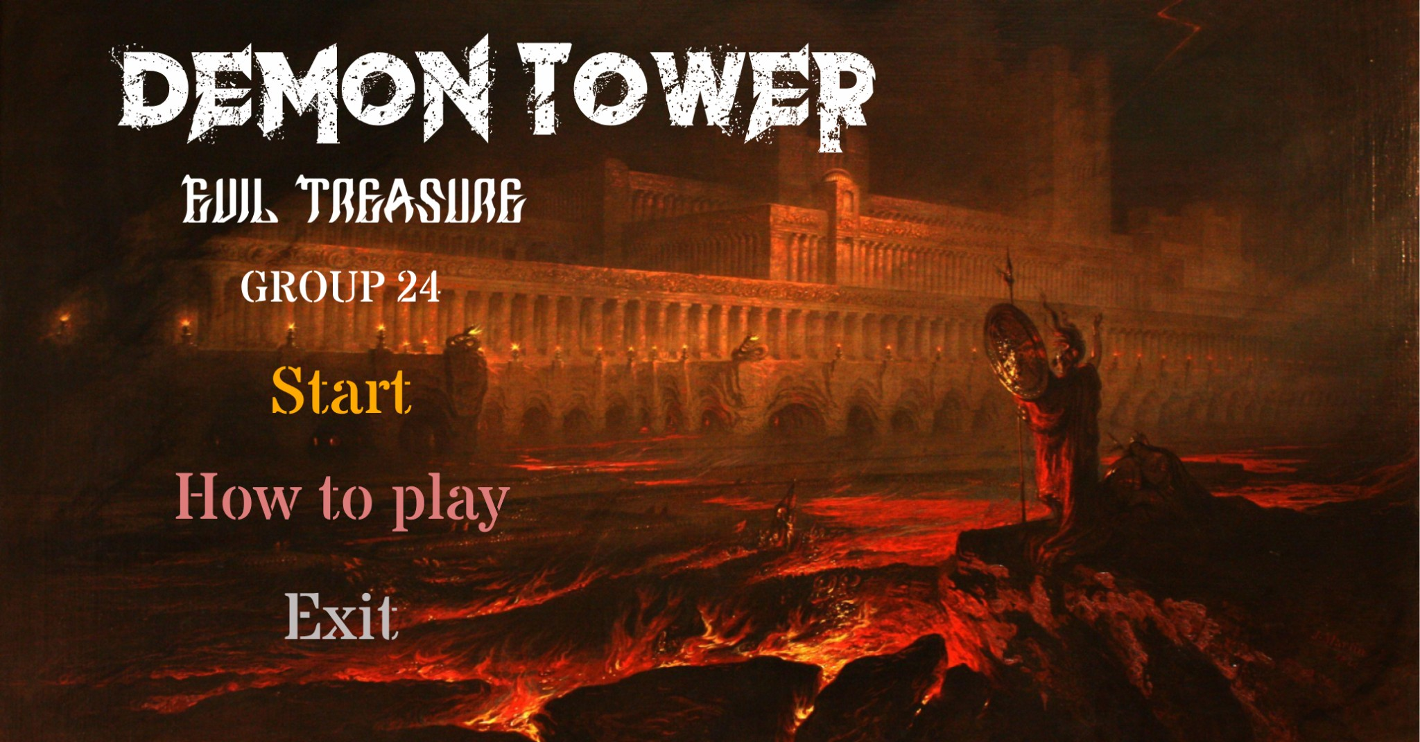

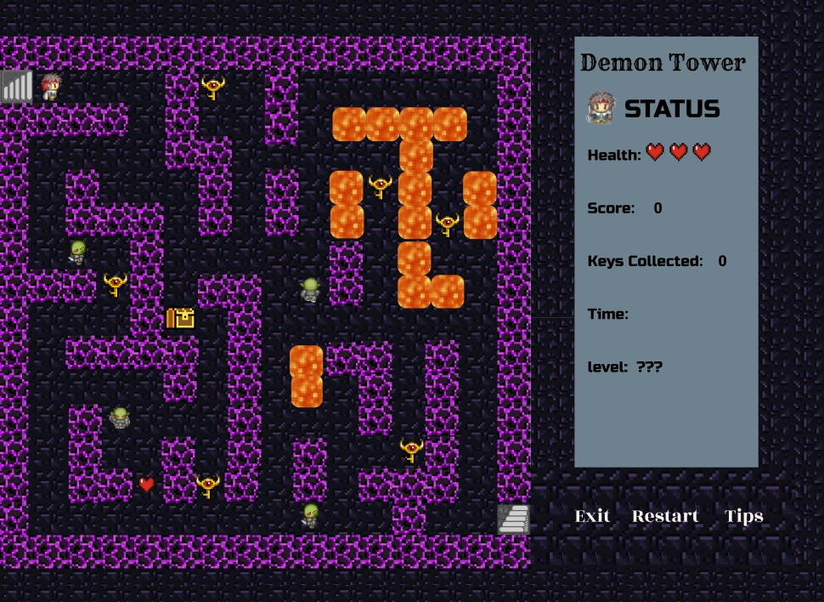

**GAME OVER**

## Score: 1000 Time: 59:00

Try again Exit

**.� CONGRATULATION!** f

We finished our mission

Score: 5000

Time: 69:00

Health: 80

# Try again

Exit